## MINI PROJECT II

## SYNOPSIS



Department of Computer Science & Application

## Institute of Engineering & Technology

SUBMITTED TO: - SUBMITTED BY: -

Mrs.Neelam Soni Harshita Mathpal(201500288) (Technical Trainer) Priya Rawat(201500523)

Yash Gupta (201500818)

# Declaration

We hereby declare that the work in the project report entitled "Eduverse " GLA University, Mathura for the award of the degree of "B.Tech" is an authentic record of my work carried out during the Sixth semester the Third year, 2023 under the supervision of Mrs. Neelam Soni. The matter embodied in this project report has not been submitted elsewhere by anybody for the award of any other degree/diploma.

|  |  |  |
| --- | --- | --- |
| S.NO | Name | University Roll No. |
| 1. | Priya Rawat | 201500523 |
| 2. | Yash Gupta | 201500818 |
| 3. | Harshita Mathpal | 201500288 |

# Acknowledgment

It gives us a great sense of pleasure to present the synopsis of the B.Tech mini-project undertaken during B. Tech III Year. This project is going to be an acknowledgment to the inspiration, drive, and technical assistance that will be contributed to it by many individuals. We owe a special debt of gratitude to Mrs. Neelam Soni , Technical Trainer, for providing us with an encouraging platform to develop this project, which thus helped us in shaping our abilities towards a constructive goal, and for his constant support and guidance to our work.

His sincerity, thoroughness, and perseverance have been a constant source of inspiration for us. We believe that he will shower us with all his extensively experienced ideas and insightful comments at different stages of the project & also taught us about the latest industry-oriented technologies. We also do not like to miss the opportunity to acknowledge the contribution of all department faculty members for their kind guidance and cooperation.

Harshita Mathpal(201500288)

Priya Rawat(201500523)

Yash Gupta(201500818)

## ABSTRACT

The website provides a platform for learners to access educational resources and courses remotely. The website's design and functionality are geared towards making online learning accessible and engaging for learners. It features a variety of multimedia resources such as videos and course booklets to facilitate learning. The website also offers a range of courses across different disciplines, with experienced instructors providing personalized feedback and support. The platform is accessible on multiple devices, making it easy for learners to study on the go. With its user-friendly interface, comprehensive course offerings, and flexible learning options, the e-learning website offers a valuable resource for anyone looking to expand their knowledge and skills through online education.

# Contents

**Declaration Acknowledgement Abstract**

1. **Introduction**
   1. Objective
   2. Project Overview
2. **Software Requirement**
   1. Hardware Requirements
   2. Software Requirements
3. **Project Description**
4. **Working**
5. **Implementation**
6. **Reference**

# INTRODUCTION

**Objective**

The primary objective of online e-learning websites named as EDUVERSE is to provide learners with an accessible and flexible platform for acquiring knowledge and skills. E-learning websites aim to offer high-quality educational content to learners of all ages and backgrounds, regardless of their location, schedule, or learning style. It helps to democratize education by providing learners with a flexible, accessible, and high-quality platform for acquiring new knowledge and skills.

**PROBLEM STATEMENT.**

Each learner has his own individual needs and characteristics.

Most of learning management system do not consider learner’s needs and preferences.

Now a days there is a high competition in e-learning website development, as we are starting a new website, we have to make it much interactive and responsive to make it beneficial to students.

**SOLUTION.**

To develop e-learning technology platform.

To design simplified and interactive website with an easy access to visually attractive content of course.

To provide study material with regular updates.

**SOFTWARE/HARDWARE REQUIREMENTS AND TECHNOLOGIES USED:**

* + - Visual Studio Code
    - PHP
    - MySQL
    - Browser
    - 4GB RAM
    - Minimum Memory - 100 MB
    - Windows 10

## PROJECT DESCRIPTION

An online education e-learning website is a platform that offers educational materials, courses, and other related resources over the internet. The website aims to provide a convenient, flexible, and accessible way for students to learn and acquire knowledge.

The following are the key features that a typical online education e-learning website should have:

Course catalog: The website should have a comprehensive catalog of courses that are available for students to enroll in. The catalog should be easy to navigate, and students should be able to search for courses based on their interests, subject matter, and level of difficulty.

Course content: The website should provide course materials such as lectures, videos, articles, quizzes, and assignments that students can access and study at their own pace. The content should be of high quality and easy to understand, and it should cover all the relevant topics and concepts.

Interactive learning tools: The website should have interactive tools such as discussion forums, live chat, and video conferencing that allow students to interact with each other and with their instructors. These tools help students clarify their doubts, collaborate with their peers, and receive feedback from their instructors.

Assessment and certification: The website should provide a system for assessing and certifying the students who complete the courses. The assessment should be based on objective criteria, and the certification should be recognized by employers and educational institutions.

User-friendly interface: The website should have a user-friendly interface that is easy to navigate and use. The interface should be responsive and compatible with different devices and browsers.

Secure and reliable: The website should be secure and reliable to ensure that students' personal information and data are safe. The website should also be able to handle a large number of users simultaneously without crashing or slowing down.

The website should also have a marketing and promotion strategy to attract students and increase their enrollment. This can include social media campaigns, email marketing, and search engine optimization.

In summary, an online education e-learning website should be designed to provide an effective and efficient way for students to learn and acquire knowledge. By incorporating the above features, the website can offer a high-quality educational experience that is accessible and convenient for everyone.

**WORKING**

The working of this e-learning website involves multiple stages of development and implementation. The following are the key steps involved in the working of this project:

1. Needs assessment: The project team will conduct a thorough needs assessment to identify the target audience, determine their learning needs, and establish the website's features and functionality.
2. Website design: The project team will design the website's interface, navigation, and search capabilities. The design will prioritize ease of use, accessibility, and engagement.
3. Course development: The project team will develop a range of courses across different disciplines. The courses will incorporate multimedia resources and innovative teaching methods to promote an engaging learning experience.

4. Instructor selection and training: The project team will select experienced instructors to provide personalized feedback and support to learners. The instructors will receive training on how to use the website's features and provide effective online instruction.

5. Website development: The website will be developed using web development tools and platforms. The website will be designed to function on multiple devices and comply with accessibility standards.

6. Testing and evaluation: The website will undergo rigorous testing to ensure that it functions as intended and provides an engaging and inclusive learning environment. The project team will also evaluate the website's effectiveness in achieving the project's objectives.

7. Launch and maintenance: Once the website is fully developed and tested, it will be launched for public use. The project team will continue to maintain and update the website to ensure that it remains accessible, engaging, and effective in meeting learners' needs. Overall, the working of this project will involve a collaborative effort between web developers, instructional designers, subject matter experts, instructors, and project managers to create a comprehensive and effective e-learning platform.

**IMPLEMENTATION**

This project is implemented by using different technologies like basic HTML , CSS3 and JavaScript for functionality . To make site smoother and more responsive. PHP is used in the backend and MySQL in Database. To manage the data of the users and to provide information efficiently MYSQL database is being used.

**What contribution would this project make and where?**

This e-learning website project has the potential to make a significant contribution to education and learning in several ways and in various locations. Some possible contributions of an e-learning website project are: Access to education: An e-learning website project can help increase access to education for people who may not have access to traditional educational institutions or who may face barriers to learning, such as geographic or economic constraints. Flexibility and convenience: E-learning allows learners to study at their own pace and in their own time. They can access learning materials from anywhere and at any time, as long as they have an internet connection. Personalized learning: E-learning allows learners to choose what they want to learn and at what pace they want to learn. They can also choose the format of the content they want to learn from, such as videos, interactive quizzes, and games. Cost-effective: E-learning can be a cost-effective alternative to traditional learning methods. It can save learners the cost of commuting to a physical location, accommodation costs, and other expenses. Global impact: E-learning website projects have the potential to reach a global audience, which can help to democratize access to education and improve global literacy rates. Overall, an e-learning website project can contribute to the advancement of education and learning by providing greater access, flexibility, and personalized learning experiences to learners across different regions and socioeconomic backgrounds

**Scope for extension into a major project.**

There are several ways in which this e-learning website project can be extended into a major project. Here are a few examples: Expansion of courses:

1. The e-learning website project can be expanded to offer more courses and topics to learners. This can be done by partnering with subject matter experts or educational institutions to create and deliver high-quality educational content.
2. Integration of additional features: The e-learning website can be extended by adding features such as virtual classrooms, interactive forums, live tutoring sessions, or a mobile application to provide a better learning experience to the learners.
3. Localization: The e-learning website project can be extended by localizing the content and features to cater to learners from different regions and cultures. This can help to expand the reach of the project and make it more accessible to learners who speak different languages.
4. Accreditation: The e-learning website project can be extended by seeking accreditation from recognized educational bodies or institutions. This can add value to the courses offered and help learners to gain recognized qualifications.
5. Research and development: The e-learning website project can be extended by investing in research and development to explore new approaches to online learning and improve the effectiveness of the platform.

**Data Flow Diagrams**

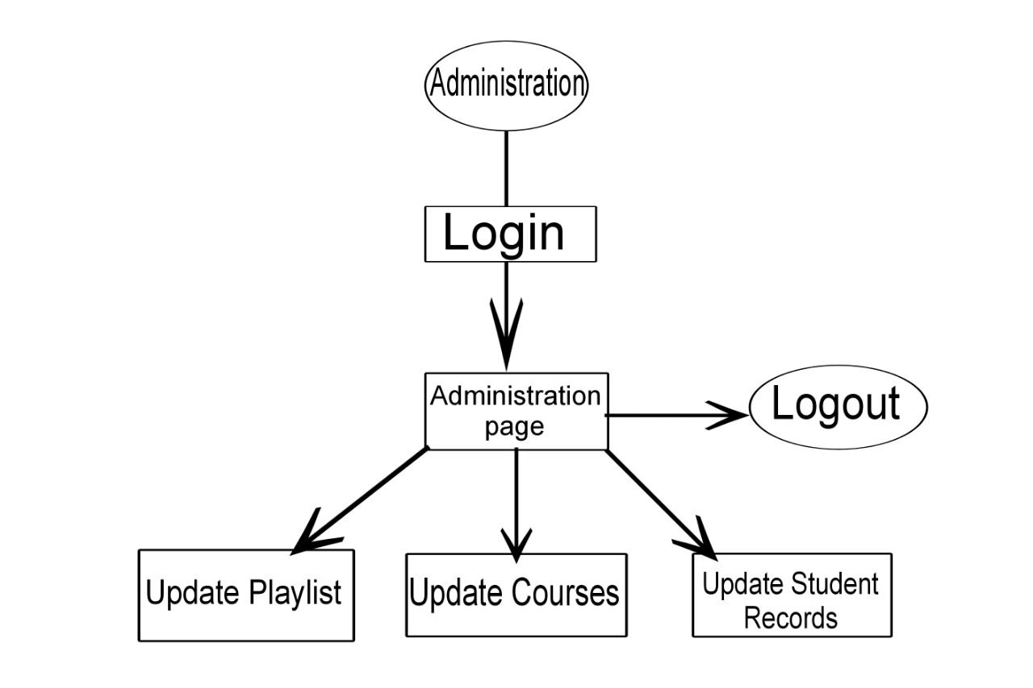

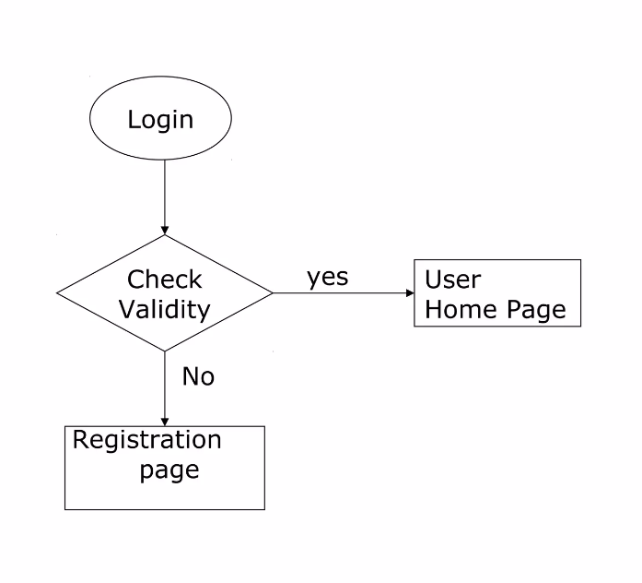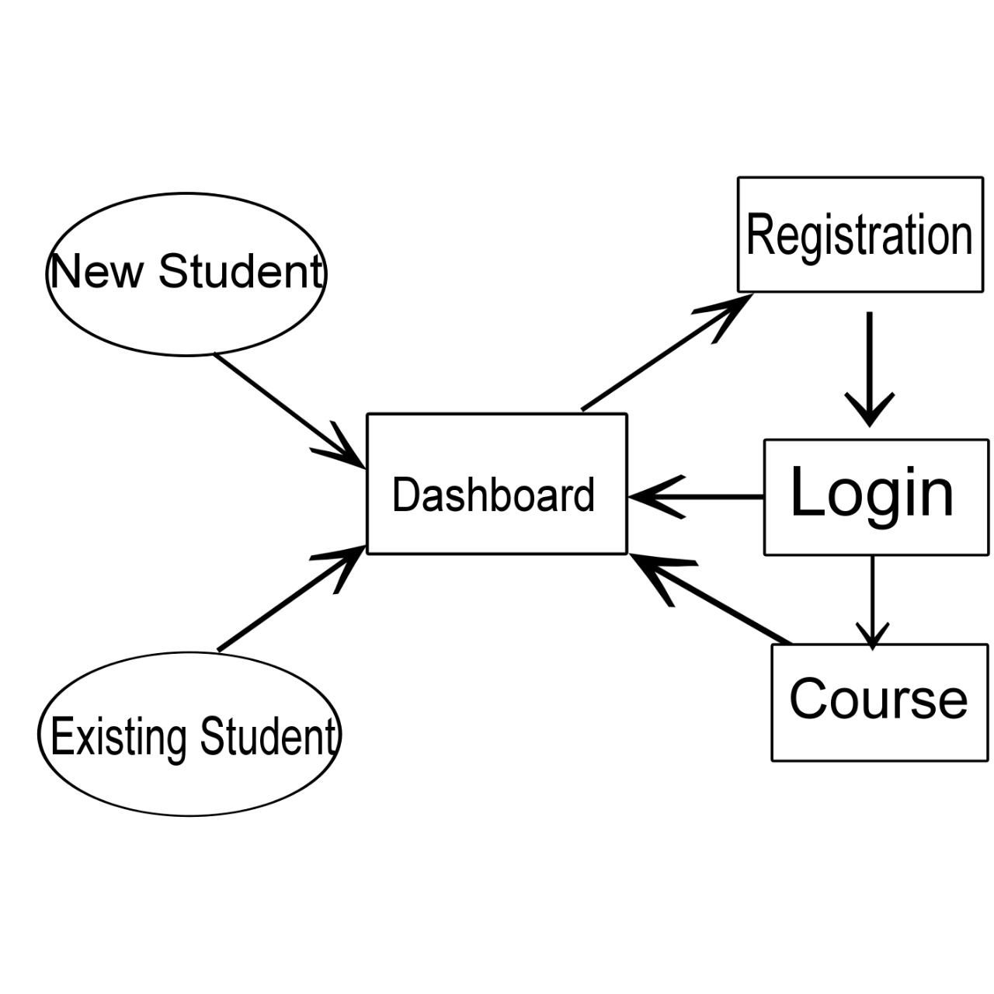

**Conclusion:**

In conclusion,this e-learning website project has the potential to make a significant contribution to education and learning by providing greater access, flexibility, and personalized learning experiences to learners across different regions and socioeconomic backgrounds. The project can be extended into a major project by expanding the courses, integrating additional features, localizing the content, seeking accreditation, and investing in research and development. Through this project, learners can gain access to high-quality educational content and resources, regardless of their location or socioeconomic status. The project can also help to democratize access to education and improve global literacy rates. Overall, an e-learning website project has the potential to make a positive impact on education and learning and can be a valuable resource for learners who are seeking to enhance their skills and knowledge in a flexible and convenient way.

**REFERENCES:**

## Websites:

* 1. https://www.geeksforgeeks.org/web-development
  2. [https://www.google.com](https://www.google.com/)
  3. https://www.php.net
  4. https://openai.com/blog/chatgpt

**Faculty Guidelines:**

Mrs. Neelam Soni (Technical Trainer at GLA University)

**GitHub Repository link:**

## https://priyarawat18.github.io/eduverse/